- Program ID : VA007MA1

- Display Layout
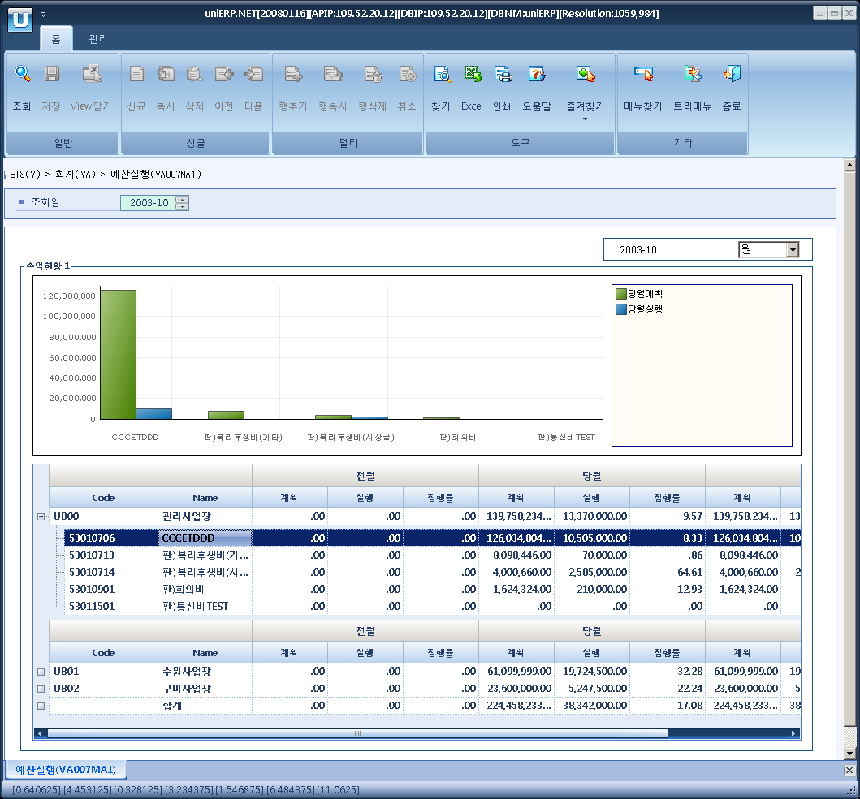

- Event flow
- Click Query button
- OnFncQuery -> DbQuery -> DataChange
- Display Unit combo change
- uniCombo1_ValueChanged -> DataChange

- SQL Statements
- Profit and Loss
SELECT CASE WHEN a.biz_area_cd IS NULL THEN 'ZZZZ' ELSE a.biz_area_cd END AS biz_area_cd,
CASE WHEN a.biz_area_cd IS NULL THEN '합계' ELSE c.biz_area_nm END AS biz_area_nm,
CASE WHEN a.bdg_cd IS NULL THEN '00000000' ELSE a.bdg_cd END AS bdg_cd,
CASE WHEN a.bdg_cd IS NULL THEN '소계' ELSE b.gp_acct_nm END AS gp_acct_nm,
yer_bdg_amt, yer_gl_amt, CASE WHEN yer_bdg_amt = 0 THEN 0 ELSE yer_gl_amt / yer_bdg_amt * 100 END AS year_rate,
bef_bdg_amt, bef_gl_amt, CASE WHEN bef_bdg_amt = 0 THEN 0 ELSE bef_gl_amt / bef_bdg_amt * 100 END AS bef_rate,
cur_bdg_amt, cur_gl_amt, CASE WHEN cur_bdg_amt = 0 THEN 0 ELSE cur_gl_amt / cur_bdg_amt * 100 END AS cur_rate
FROM (SELECT a.biz_area_cd, a.bdg_cd,
ISNULL(SUM(CASE WHEN a.bdg_yyyymm <= @strYYYYMM THEN a.bdg_amt ELSE 0 END), 0) AS yer_bdg_amt, -- 누적예산
ISNULL(SUM(CASE WHEN a.bdg_yyyymm <= @strYYYYMM THEN a.bdg_gl_amt ELSE 0 END), 0) AS yer_gl_amt, -- 누적실행
ISNULL(SUM(CASE WHEN a.bdg_yyyymm = SUBSTRING(CONVERT(VARCHAR, DATEADD(month, -1, @strYYYYMM + '01'), 112), 1, 6) THEN a.bdg_amt ELSE 0 END), 0) AS bef_bdg_amt, -- 전월예산
ISNULL(SUM(CASE WHEN a.bdg_yyyymm = SUBSTRING(CONVERT(VARCHAR, DATEADD(month, -1, @strYYYYMM + '01'), 112), 1, 6) THEN a.bdg_gl_amt ELSE 0 END), 0) AS bef_gl_amt, -- 전월실행
ISNULL(SUM(CASE WHEN a.bdg_yyyymm = @strYYYYMM THEN a.bdg_amt ELSE 0 END), 0) AS cur_bdg_amt, -- 당월예산
ISNULL(SUM(CASE WHEN a.bdg_yyyymm = @strYYYYMM THEN a.bdg_gl_amt ELSE 0 END), 0) AS cur_gl_amt -- 당월실행
FROM f_bdg a
WHERE bdg_yyyymm BETWEEN '200301'
AND '200312'
GROUP BY a.biz_area_cd, a.bdg_cd WITH ROLLUP) a
LEFT JOIN f_bdg_acct b
ON b.bdg_cd = a.bdg_cd
LEFT JOIN b_biz_area c
ON c.biz_area_cd = a.biz_area_cd
ORDER BY a.biz_area_cd, a.bdg_cd

